# Nour

## Definition

**# Source**: **Chatgpt (GPT-5-Standard) at [8/27/2025]**

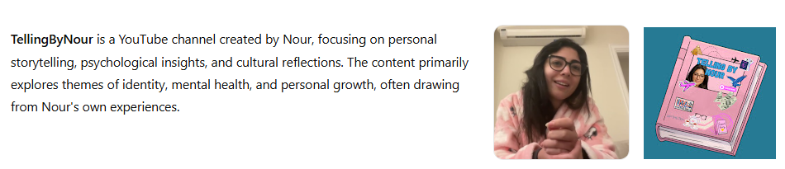

**TellingByNour** is a YouTube channel created by Nour, focusing on personal storytelling, psychological insights, and cultural reflections. The content primarily explores themes of identity, mental health, and personal growth, often drawing from Nour's own experiences.

## Key Highlights

**# Source**: **Chatgpt (GPT-5-Standard) at [8/27/2025]**

* **Content Themes**: Personal narratives, psychological exploration, and cultural commentary.
* **Community Engagement**: Emphasis on authenticity and introspection in content creation.
* **Subscriber Count**: Approximately 49.9K subscribers.
* **Video Count**: Around 116 videos.
* **Content Style**: A blend of personal storytelling, psychological insights, and cultural commentary.([Reddit](https://www.reddit.com/r/NewTubers/comments/1bi6yeo/do_you_tell_people_about_your_youtube_channel/?utm_source=chatgpt.com))

## Summary Table

**# Source**: **Chatgpt (GPT-5-Standard) at [8/27/2025]**

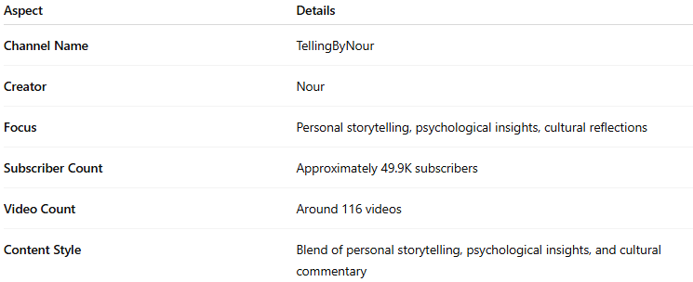

| **Aspect** | **Details** |
| --- | --- |
| **Channel Name** | TellingByNour |
| **Creator** | Nour |
| **Focus** | Personal storytelling, psychological insights, cultural reflections |
| **Subscriber Count** | Approximately 49.9K subscribers |
| **Video Count** | Around 116 videos |
| **Content Style** | Blend of personal storytelling, psychological insights, and cultural commentary |